**Digital Design and Computer Organisation Laboratory**

**UE22CS251A**

**3rd Semester, Academic Year 2023**

Date: 15-11-2023

|  |  |  |
| --- | --- | --- |
| Name: Siri N Shetty | SRN: PES2UG22CS556 | Section: J |

Week#____8_______Program Number: ____1___

TITLE: **Microprocessor Control Logic – 1**

1. Verilog Code Screenshot (alu.v)

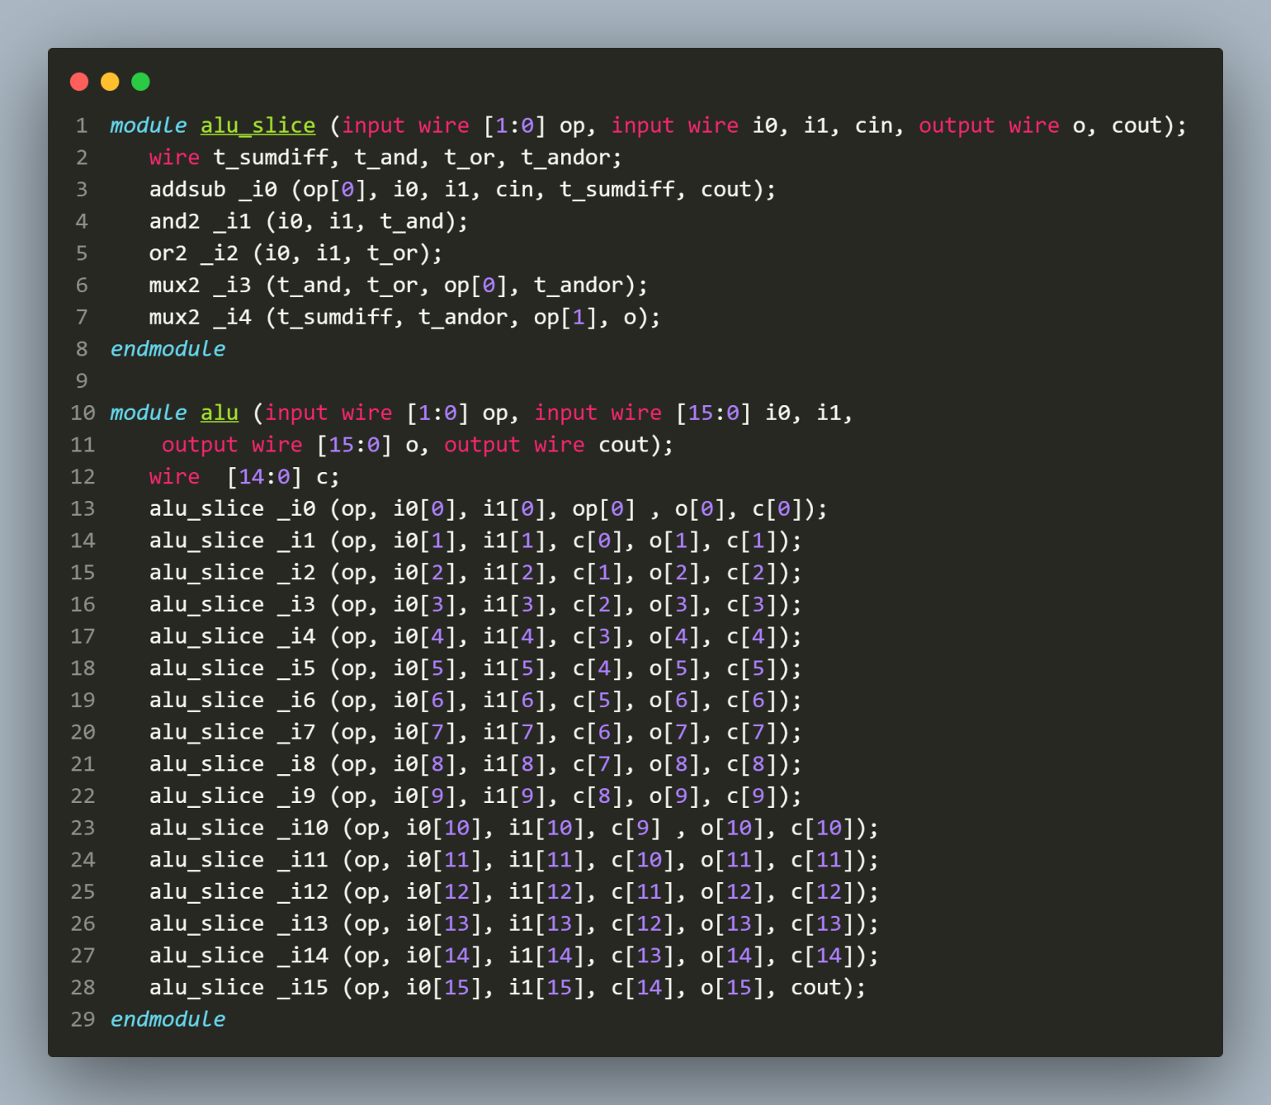

1. Verilog Code Screenshot (lib.v)

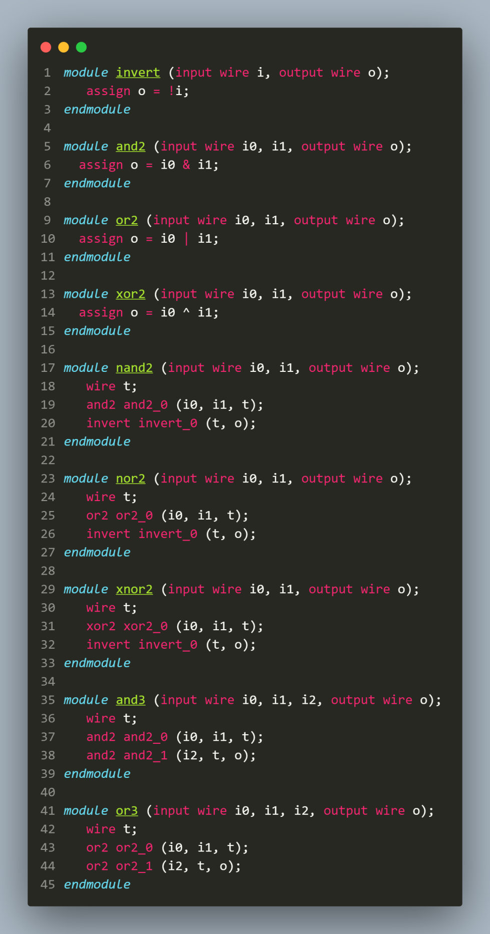

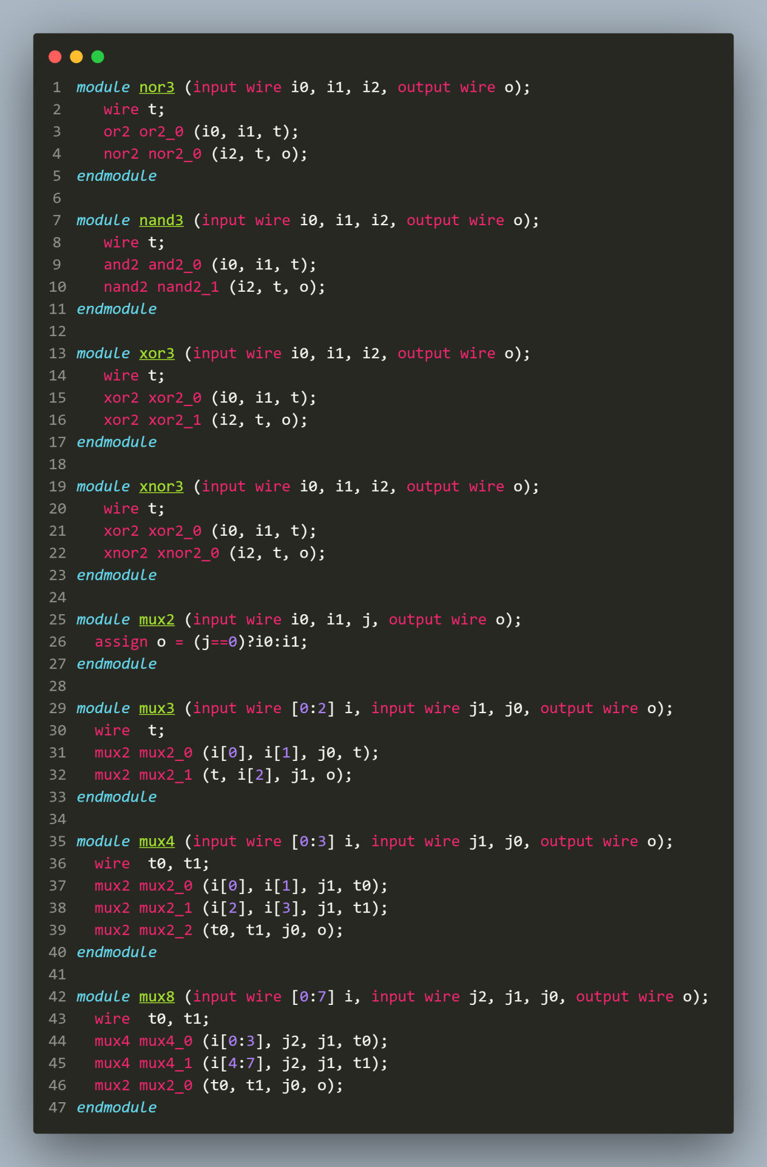

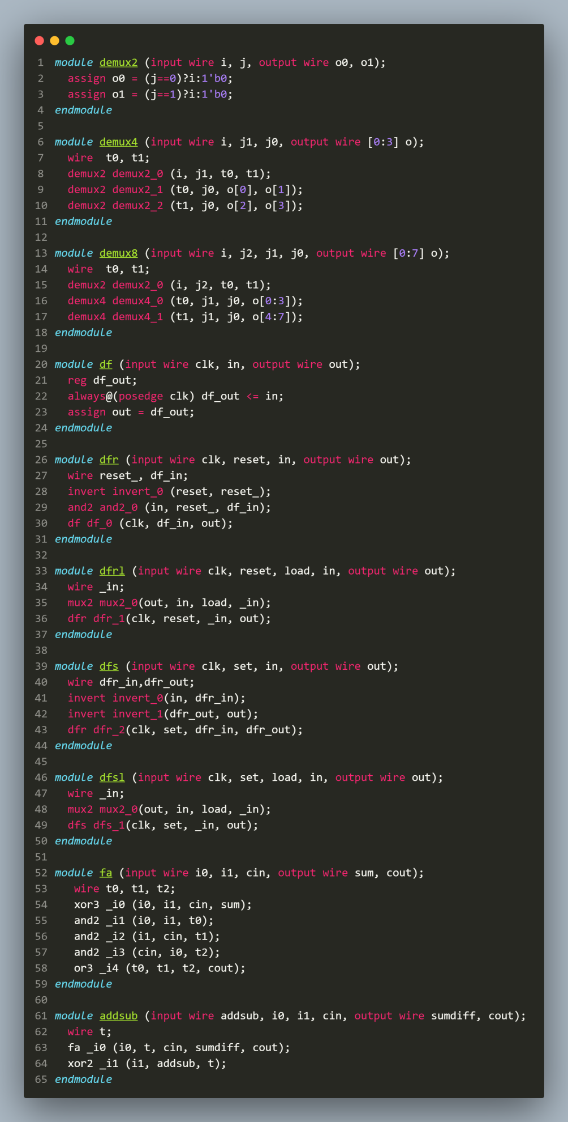

1. Verilog Code Screenshot (mproc_mem.v)

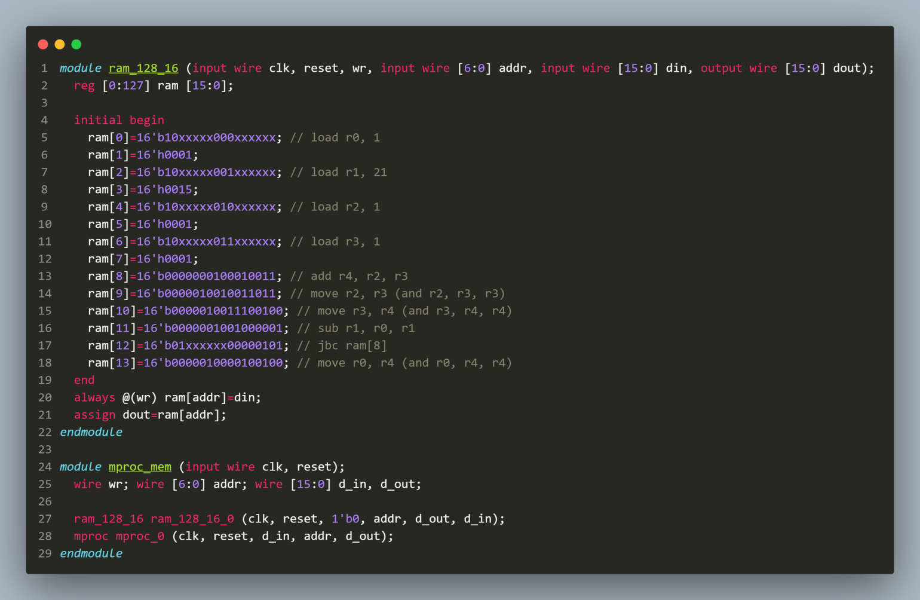

1. Verilog Code Screenshot (reg_alu.v)

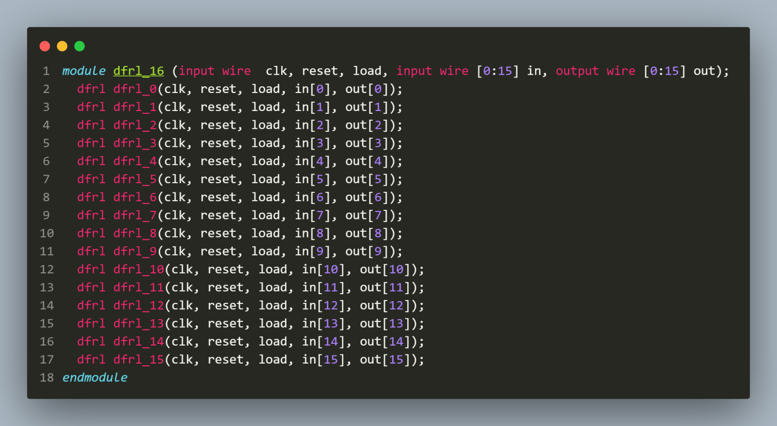

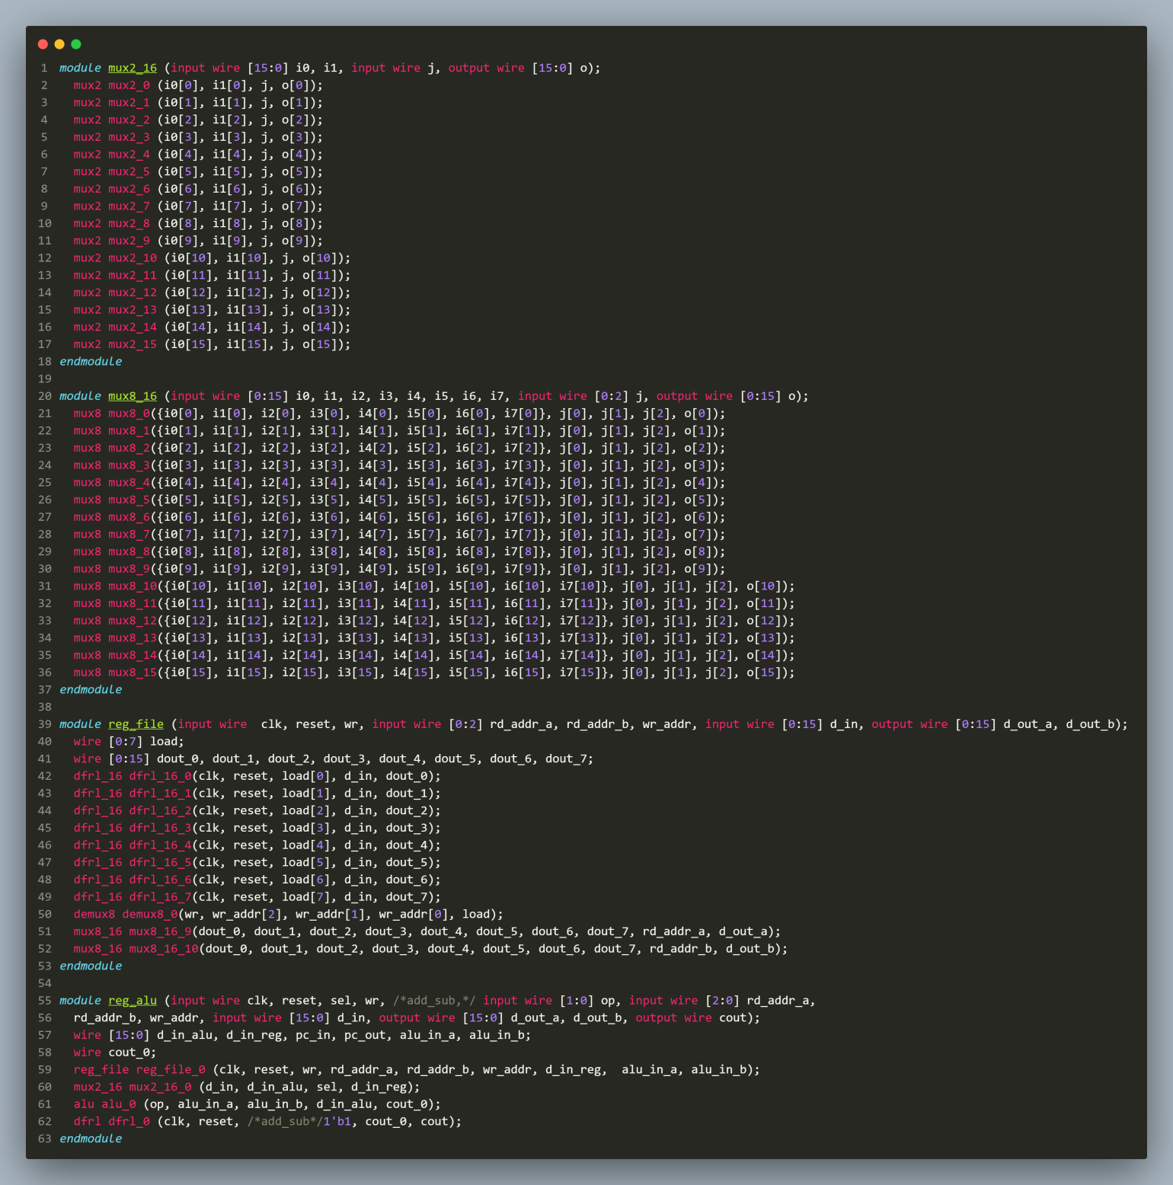

1. Verilog Code Screenshot (mproc.v)

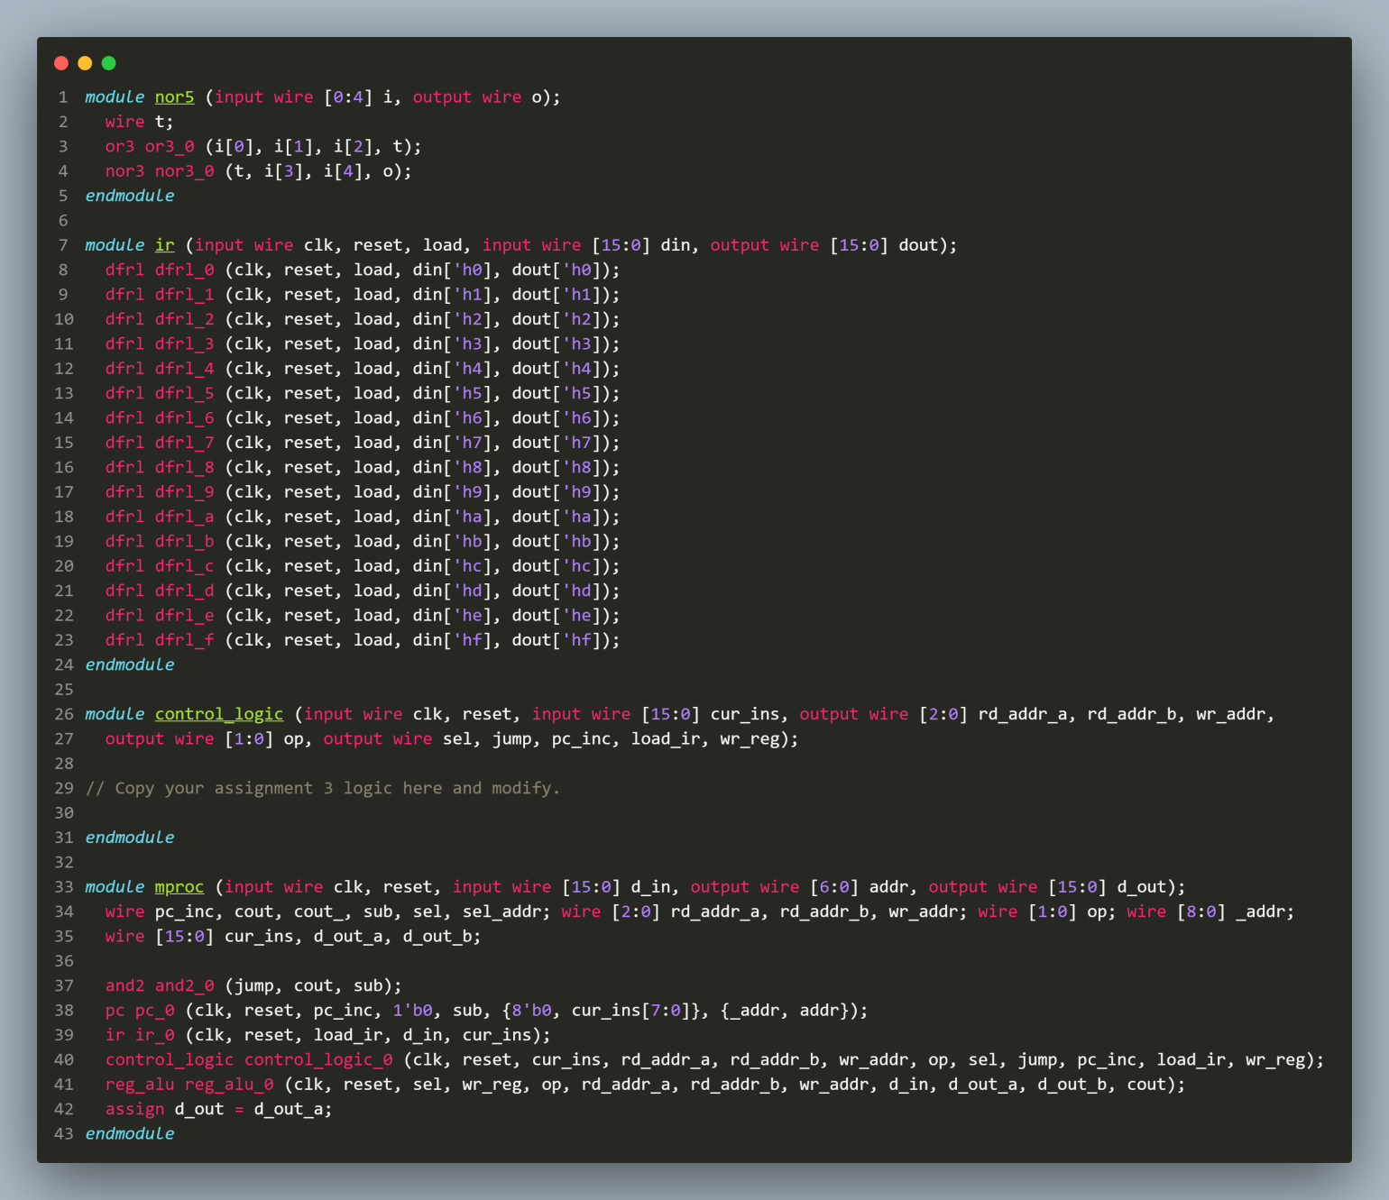

1. Verilog Code Screenshot (pc.v)

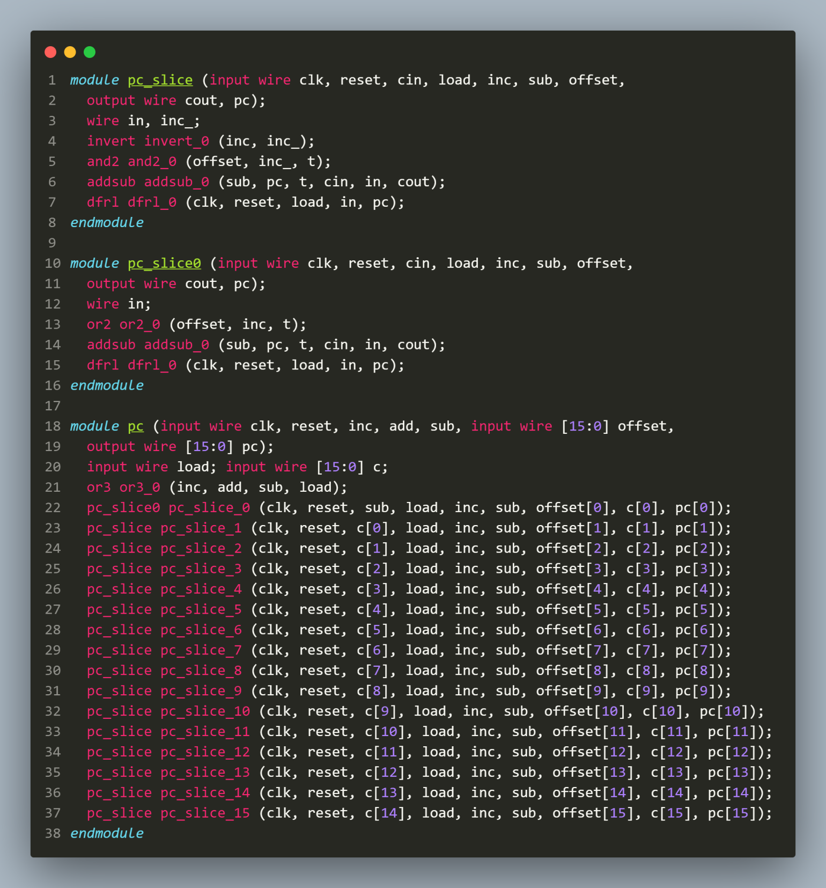

1. Verilog Code Screenshot (tb_mproc_mem.v)

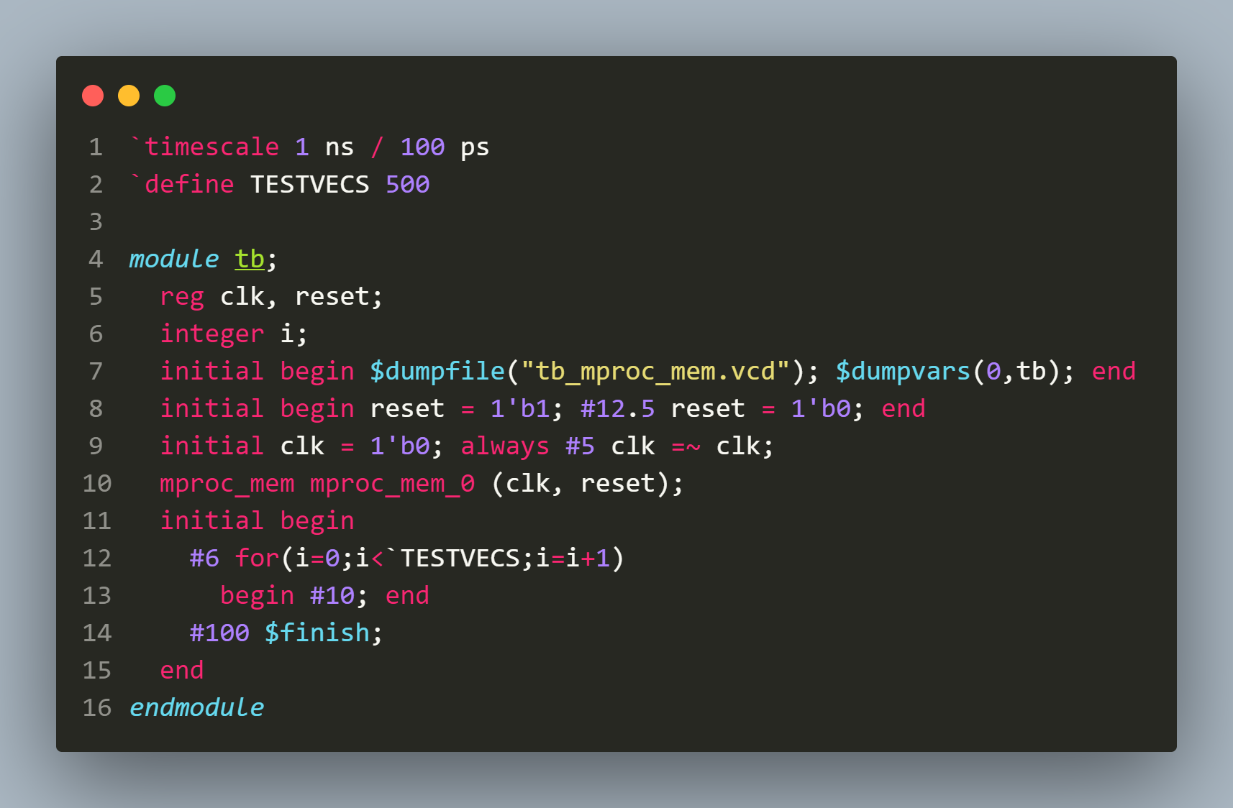

1. Verilog VVP Output Screen Shot

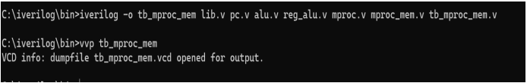

1. GTKWAVE Screenshot

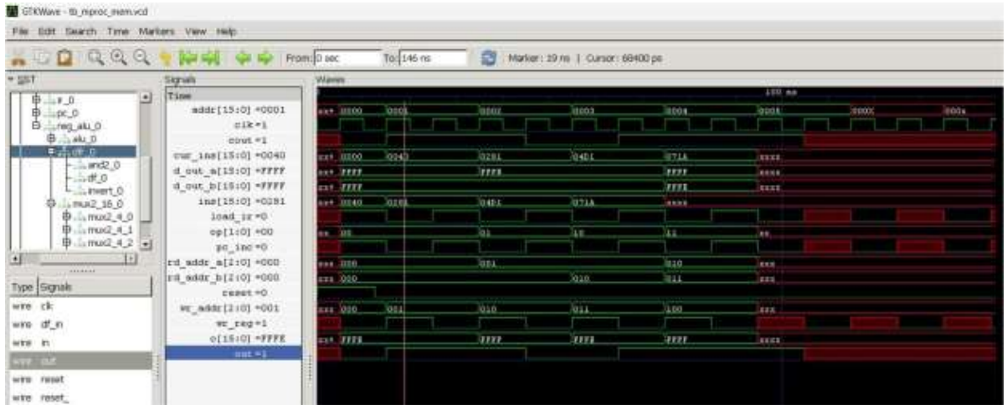

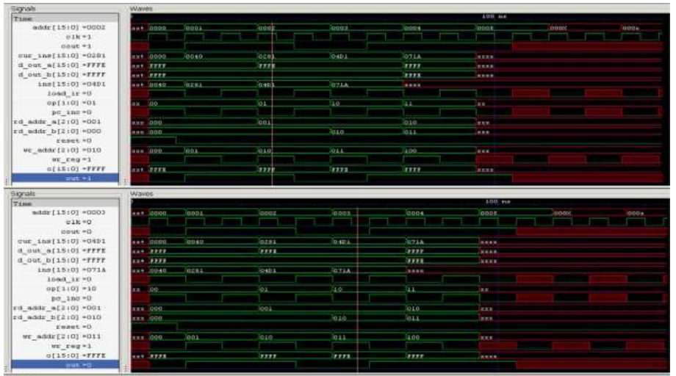

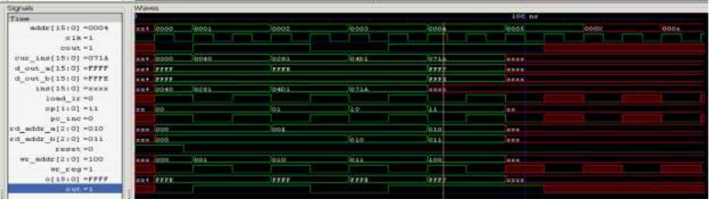

1. Output Table to be completed and included

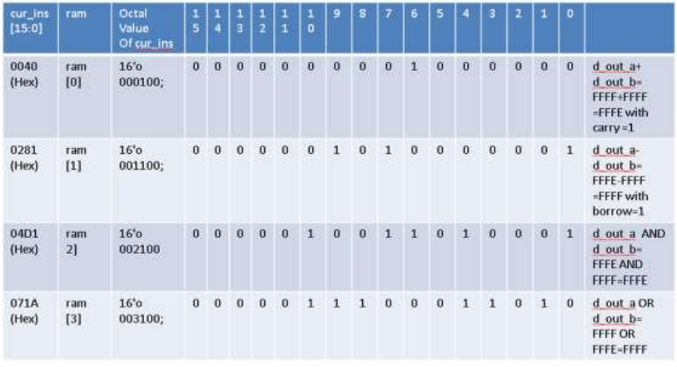

**Disclaimer:**

* The programs and output submitted is duly written, verified and executed by me.
* I have not copied from any of my peers or from the external resource such as internet.
* If found plagiarized, I will abide with the disciplinary action of the University.

Signature:

Name: Siri N Shetty

SRN: PES2UG22CS556

Section: J

Date: 15-11-2023

------------